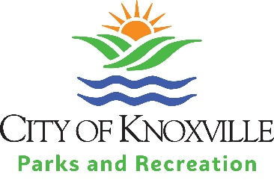
REFUND POLICIES
A participant who “no shows” or withdraws after a deadline is not entitled to a refund.
Please see below for policies specific to certain areas.
Knoxville Arts Center (KAC)
Participant Withdrawal from Class
- A participant who withdraws from a class must inform KAFCC prior to the close of registration for the class to receive a full refund.
- A participant who withdraws from a class after the close of registration for the class will receive a refund or credit of 30% of the registration fee.
- Long (4, 6 or 8-week) class registration ends one (1) week prior to the start date of that class.
- Short (1, 2 or 3-day) workshop and class registration ends three (3) days before class.
Classes Canceled Due to Low Registrations
- Participants will receive a full refund or credit on their account if KAFCC cancels the class due to low enrollment.
- All classes scheduled at Knoxville Arts & Fine Crafts Center require a minimum number of participants. KAFCC makes every effort to inform people in advance of cancellations. Long (4, 6 or 8-week) classes that do not meet the minimum registration requirement are cancelled one (1) week prior to the start date of that class. Short (1, 2 or 3-day) workshops and classes that do not meet the minimum registration requirement are cancelled three (3) days prior to the start date of that class/workshop.
- All participants will be informed via email if the class is cancelled.
COMING SOON
Adult Sports Leagues

Youth Sports Leagues

Drop In Classes

Rentals
Building Rentals
Shelter Rentals
Field Rentals
Pool Rentals

